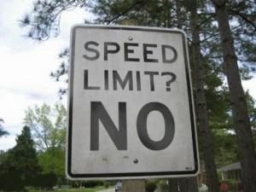

Appeal to Common Practice is when you think something is fine to do because everyone else is doing it. X is a common action; therefore X is correct or justified. This picture I found represents the Appeal to Common Practice because people think its okay to speed since everyone else is doing it. Although this action is against the law and not safe to do, people think it is still okay to do since a lot of people do it.

